Password Security Analysis
Report Date: January 20, 2026

1. Password Storage: Hashing vs. Encryption
Storing passwords in plain text is a critical security failure. Two primary methods exist for securing them:
- Encryption: A reversible two-way process. If an attacker gains the key, they can recover all passwords.
- Hashing: A one-way cryptographic transformation. A hash function takes an input and produces a fixed-size string. It is mathematically "hard" to reverse. Modern systems rely on hashing combined with "salts" (random data unique to each user).

2. Identification of Hash Types
Algorithm | Hash Length | Security Status | Notes
MD5 | 128 bits | Insecure | Fast; susceptible to collision and rainbow table attacks.
SHA-1 | 160 bits | Deprecated | Broken by collision attacks; no longer recommended.
SHA-256 | 256 bits | Secure | Strong, but very fast (good for data integrity, risky for passwords).
Argon2 / bcrypt | Variable | Highly Secure | Specifically designed to be slow and memoryintensive to thwart hardware acceleration.

3. Generation of Password Hashes
Demonstrating how the same password (Password123) appears in different formats:
MD5: 42f749ade7f9e195bf475f37a44cafcb
SHA-1: b2e98ad6f6eb8508dd6a14cfa704bad7f05f6fb1
SHA-256: 008c70392e3abfbd0fa47bbc2ed96aa99bd49e159727fcba0f2e6abeb3a9d601
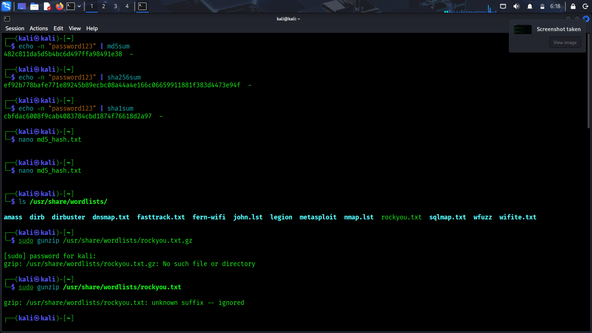
PBKDF2 (SHA-256 + Salt):
709a36
f99dfd95fe4deab6ebcadc67a926b810b88c7e571530e19b1607cddbe4...
4
. Cracking Analysis: Dictionary vs. Brute Force
Dictionary Attack Simulation:
Target Password:
Password123
Result: Password found in wordlist.
Attempts: 7 | Time Taken: 0.00002027 seconds.
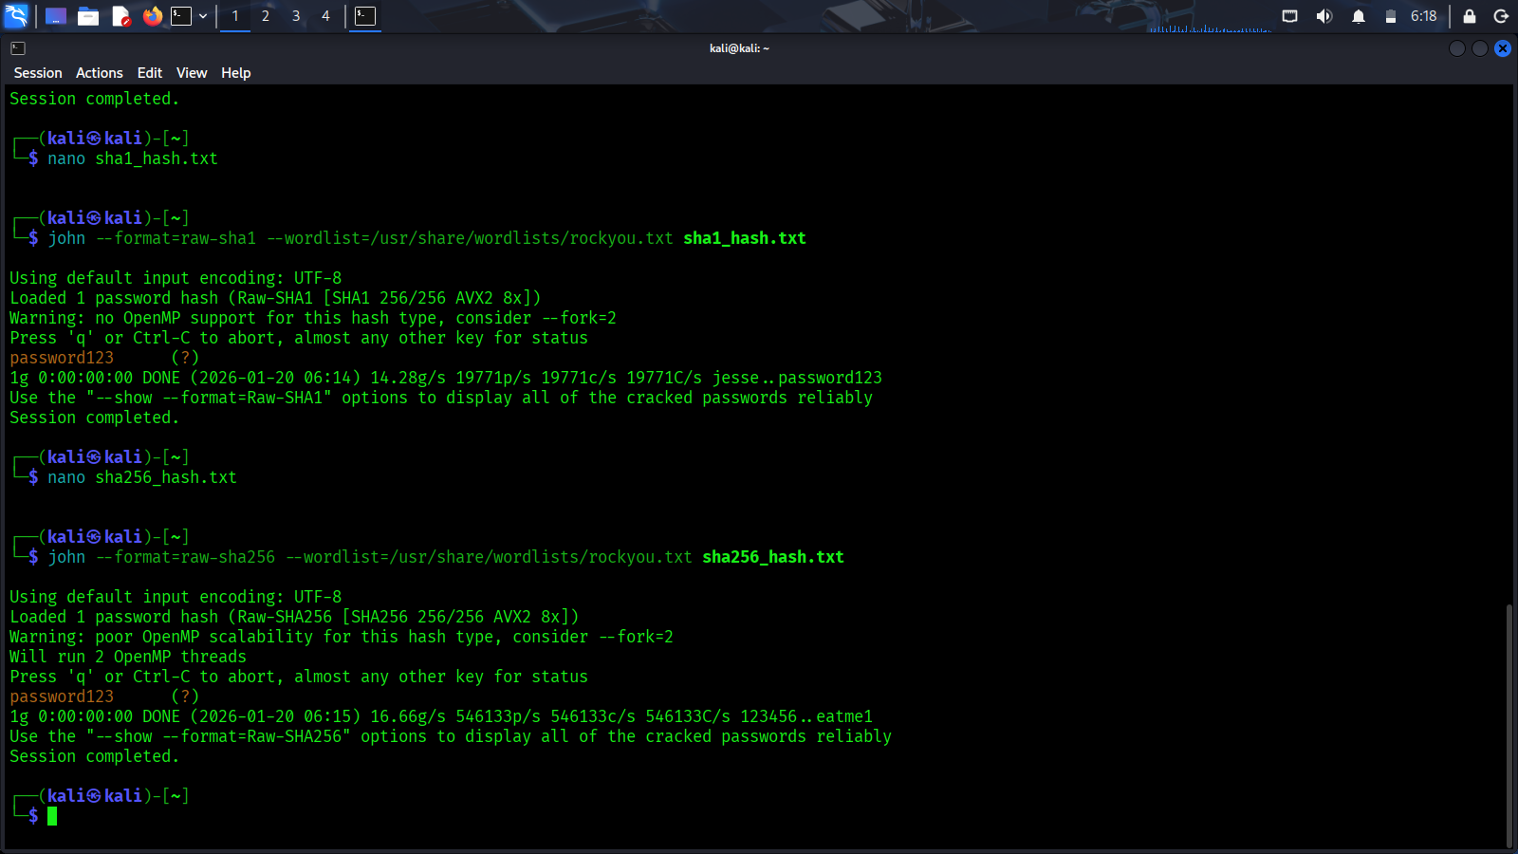

Dictionary Attacks rely on the fact that humans choose predictable passwords. Using a wordlist like "RockYou," an attacker can test millions of passwords per second.
Brute Force Attacks are exhaustive. They try every possible string (aaa, aab, aac...). While they eventually succeed, they are computationally expensive for long, complex strings.

5. Analysis: Why Weak Passwords Fail
Weak passwords fail because they are "low entropy." They are either short enough to be brute-forced or common enough to be in a dictionary. When a database leak occurs, attackers use offline tools to verify these hashes without triggering login lockouts on the actual server.

6. Multi-Factor Authentication (MFA)
MFA is the single most effective defense against password-based attacks. It requires
"something you know" (password) and "something you have" (phone, YubiKey) or "something you are" (biometrics). Even if a password hash is cracked, the account remains inaccessible without the second factor.

7. Recommendations for Strong Authentication
- Password Managers: Use unique, randomly generated 16+ character passwords for every service.
- Adaptive Hashing: Developers should use Argon2id or bcrypt with high work factors.
- Salt Everything: Never hash a passwor without a unique per-user cryptographically random salt.

Enforce MFA:
Enable TOTP (Time-based One-Time Password) on all critical
accounts.
4
.

